
Name: Sana Manzoor
Section: BSSE-4A
ROLL NO:015
Subject: AI LAB
TASK#3
- Trace BFS and DFS manually on the supplied graph. Use the----- original A–G graph from Section 3.2 and start A, goal G. Draw or tabulate each queue/stack state, processed node and path. Follow the supplied successor order and stop on goal processing. Report the final path and visit order separately; verify your trace against the supplied BFS/DFS code.
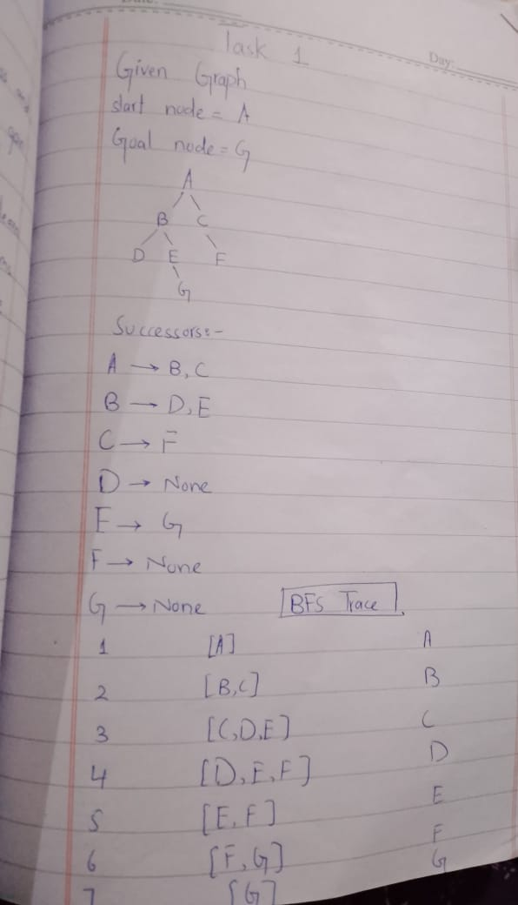
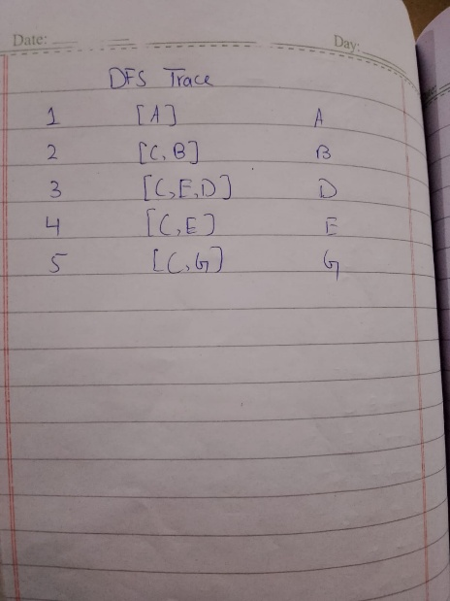
BFS
Final Path: A → B → E → G
Explanation: First, BFS visits A. Then it visits B and C. After that, it visits D, E and F. When G is processed, the search stops. The path from A to G is A → B → E → G.
DFS
Final Path: A → B → E → G
Explanation: DFS starts from A and visits B first. Then it visits D, but D has no further node. So it returns to B and visits E. From E, it reaches G and stops.
TASK#2
Implement DLS and IDDFS and test limits 1, 2, 3 and 4. Use the same original graph, counting the root at depth 0. Implement a path-local cycle check and distinguish FOUND, CUTOFF and FAILURE. Run DLS at each listed limit and run IDDFS with maximum depths 1, 2, 3 and 4. Report status, path and limits attempted; explain repeated work and why limits below 3 do not succeed.
Given Information
- Start Node: A
- Goal Node: G
- Depth Limits: 1, 2, 3, 4
- Root depth: 0
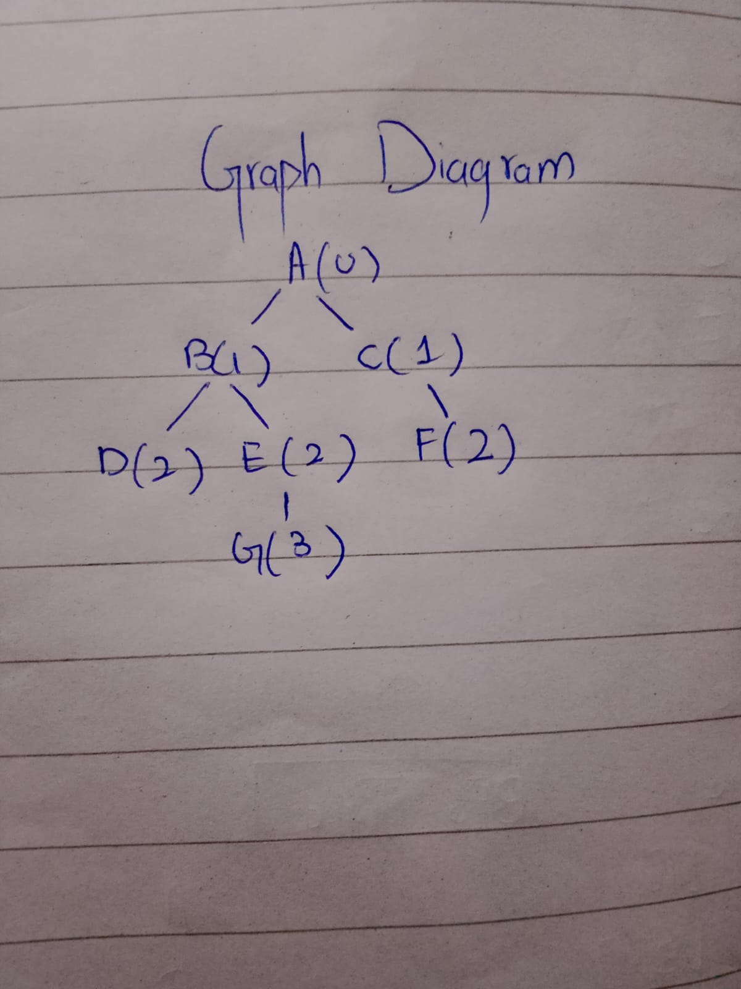
Manual Trace
Limit = 1
- A is at depth 0.
- B and C are at depth 1.
- The search cannot go deeper.
- G is not found.
Status: CUTOFF
Limit = 2
- A __ B __ D
- A __ B __ E
- A __C __F
- The search cannot go to depth 3, where G is located.
Status: CUTOFF
Limit = 3
- A __B __ D: D has no successors.
- A __B __ E __ G: Goal found.
Status: FOUND
Path: A __B __ E __G
Limit = 4
- The search follows the same successor order.
- It finds G at depth 3 before reaching the maximum limit.

